NEW ENGLAND STATES
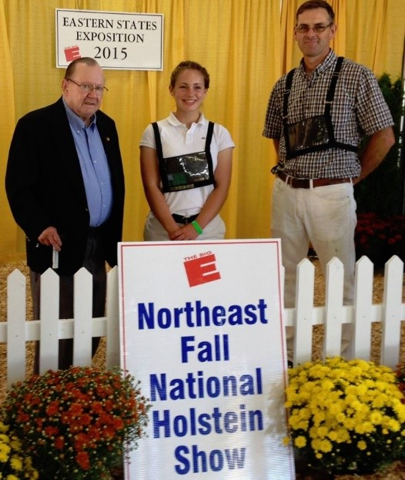
Lee Salonen and Chris Kimball present the first award in 2015 to Maggie Kirby of Vermont.
The New England States Holstein Association is proud to announce the 7th annual Lee Salonen Outstanding Holstein Junior Exhibitor Award. This award recognizes New England Junior Holstein Exhibitors for their efforts and interest in all aspects of the Holstein industry. Recipients of this award have a high level of participation in junior programs, excel in herdsmanship, are knowledgeable of their Holstein project cattle, have demonstrated leadership qualities, and have a sustained commitment to the Holstein breed.
Lee Salonen was a member of the New England States Holstein Association for 56 years. He rendered tireless service on the board for 33 years in nearly every leadership position including President, Vice-President, Treasurer, Assistant Treasurer, Finance Chair and Finance Chair for the 2005 National Holstein Convention hosted by the New England States Holstein Association. Lee was also a recipient of the New England Association’s prestigious Distinguished Service award. Providing opportunities for Holstein youth to grow within the industry was the cornerstone of Lee’s leadership philosophy.

NEW ENGLAND STATES
GENERAL GUIDELINES
- Award to be a $500 cash prize, presented at the ESE Northeast Fall National Holstein Show in honor of Lee Salonen.
- Recipient must be a New England and National Junior Holstein member and may win this award only once.
- Youth must exhibit their own Holsteins at the ESE Northeast National Show in the year in which the applicant has applied.
- Selection will be completed by an anonymous committee.
SELECTION CRITERIA
- SPORTSMANSHIP
Applicants must represent the highest standards in good sportsmanship, display courtesy and congeniality to other exhibitors, cooperation with show management and willingness to share skills with others. Applicants must be present at the show over the course of two days.
- HERDSMANSHIP
Applicants must demonstrate the highest ideals of animal care and welfare, efficiency and a strong work ethic in their exhibit and cattle and outwardly display working knowledge of this portion of the dairy industry. Applicants must be present at the show over the course of two days.
- LEVEL OF PARTICIPATION IN HOLSTEIN ACTIVITIES
Applicants must illustrate their level of participation in HOLSTEIN activities on a local, state, and national level.
- LEVEL OF PARTICIPATION IN 4-H, FFA, OR OTHER YOUTH DAIRY
ORGANIZATIONS
Applicants must illustrate their level of participation in 4-H, FFA, or other youth dairy organizations.
APPLICATIONS MUST BE POSTMARKED BY SEPTEMBER 1ST AND SEND TO:
The New England States Holstein Association, Inc.
234 Bayley Hazen Drive, Wells River, Vermont 05081

2023 APPLICATION FORM – 3 PAGES
**Also available on our website (nesholsteins.com) as a fillable pdf form.
Name:______________________________________________ Mailing address:______________________________________
Telephone number with area code:_______________________
Email:______________________________________________
Age:___________Birth date:_____________________
College:_________________________Graduation date:______
High School:_____________________Graduation date:______
Parents’ names:_______________________________________ How many years have you been a NE junior member?:____
How many years a Holstein USA junior member?:____
Number of years showing Holsteins?:_______________
Number of years showing Holsteins in 4-H at the Big E?:_____
How many years have you exhibited at the Northeast Fall
National Holstein Show?:______

What Holstein classes are you entered in at ESE this Year?
____________________________________________________ ____________________________________________________
List the farm name in which your animals will be stalled at ESE:________________________________________________
____________________________________________________ ____________________________________________________

What are your future plans/goals within the Holstein industry?
____________________________________________________ ____________________________________________________
____________________________________________________
____________________________________________________
____________________________________________________
____________________________________________________
____________________________________________________
____________________________________________________ ____________________________________________________ ____________________________________________________ ___________________________________________________
List your participation in junior New England and Holstein USA by year:
____________________________________________________ ____________________________________________________
____________________________________________________
____________________________________________________
____________________________________________________
____________________________________________________ _____________________________________________
List your participation in other activities (agricultural and/or school/community) by year:
____________________________________________________ ____________________________________________________
____________________________________________________
____________________________________________________ ____________________________________________________ ____________________________________________________
____________________________________________________
____________________________________________________
What kind of leadership role do you envision yourself having in the Holstein
Industry in the future? WHY? (150 words or less)
____________________________________________________ ____________________________________________________
____________________________________________________
____________________________________________________
____________________________________________________
____________________________________________________ ____________________________________________________ ____________________________________________________
____________________________________________________
____________________________________________________
____________________________________________________
____________________________________________________
____________________________________________________
____________________________________________________ ____________________________________________________ ____________________________________________________
____________________________________________________
____________________________________________________
____________________________________________________ ____________________________________________________ ____________________________________________________
Continued: ____________________________________________________________________________________________________________________________________________________________________________________________________________________________________________________________________________________________________________________________________________________________________________________________________________________________________________________________________________________________________________________________________________________________________________________________________________________________________________________________________________________________________________________________________________________________________________________________________________________________________________________________________________________________________________________________________________________________________________________________________________________________________________________________________________________________________________________________________

